Washtenaw Intermediate School District
Early Childhood Programs
Head Start and Early Head Start of Washtenaw County
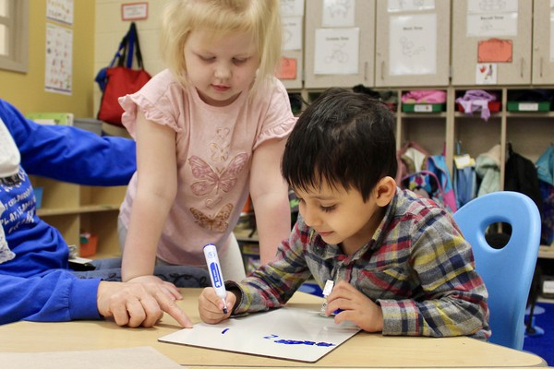

PRENATAL - FIVE YEARS OF AGE

HEAD START

ANNUAL REPORT

2022-2023
Contents
General Information 4
Mission, Vision & Values 5
Mission 5
Vision 5
Values 5
Sub-recipients, Partner Agencies and Recipient 6
Locations 7
Grantee Budget 8
Early Childhood 2022-2023 Funding 8
Washtenaw ISD Early Childhood Department Budget Breakdown 8
Recruitment 10
Enrollment 11
Percentages of Eligible Children Served and Services Provided 11
Enrollment PIR Performance Indicator 11
Attendance 12
Nutrition 12
Health PIR Performance Indicator 13
Pregnant Women – Health Services 14
Family Information 15
Family Service PIR Performance Indicator 15
Parent Involvement & Family Engagement 16
Community Engagement 16
Disability and Mental Health Services 19
Disability Service PIR Performance Indicator 19
Education – Supporting High Quality Preschool Classrooms 20
Professional Development 23
New Staff Orientation 24
The Pajama Program 25
A Parent Follow Up survey was conducted in May 2023. 25
Summer Health Expos 27
2022 WISD Early Childhood Conference 29

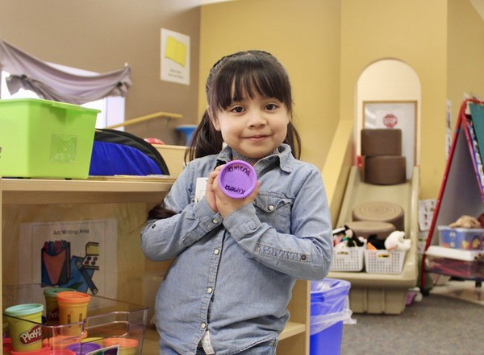
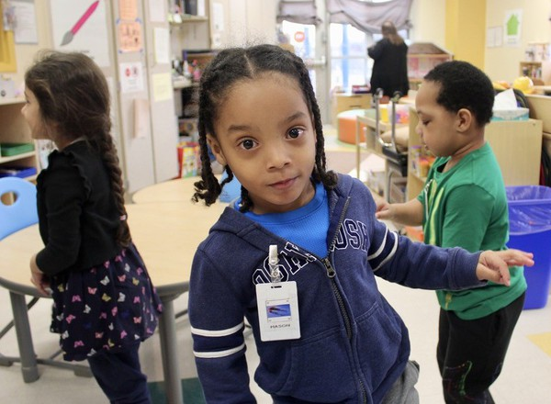

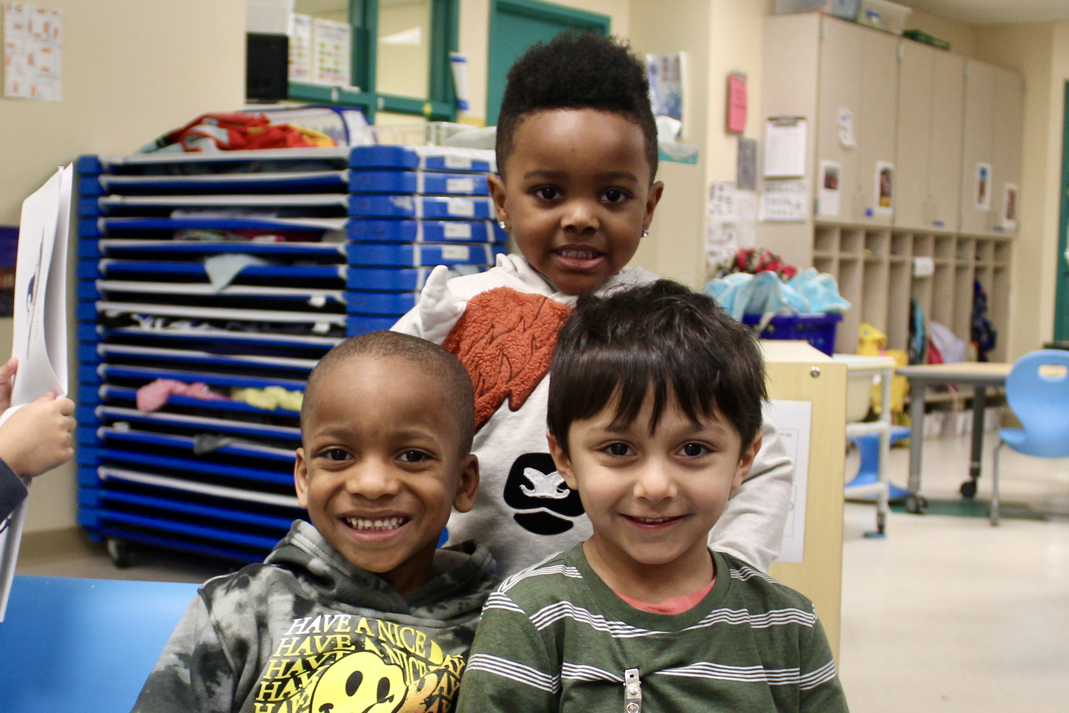

General Information
Recipient: Washtenaw Intermediate School District - Early Childhood Department
Washtenaw Intermediate School District - Early Head Start
Sub-recipient: Ann Arbor School District
Whitmore Lake Public Schools
Ypsilanti Community Schools
Partner Agency: Lincoln Consolidated Schools

Grant Number: 05CH010612

Address: 1819 South Wagner Road, Ann Arbor, MI 48106-1406
Phone: 734-994-8100
Fax: 734-994-2203
Agency Website: www.washtenawisd.org/departments/early-childhood

Agency Type: Recipient and Sub-recipient

Agency Description: Washtenaw Intermediate School District – Early Childhood Department is a Head Start and Early Head Start Grantee that provides services through delegate and partner agencies throughout Washtenaw County, Michigan.

Executive Director of Early Childhood Programs: Edward Manuszak - emanuszak@washtenawisd.org
Early Head Start & Family Services Supervisor: Alicia Kruk - akruk@washtenawisd.org

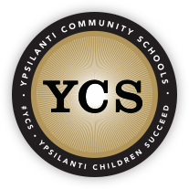

Mission, Vision & Values

Mission
Washtenaw Intermediate School District’s mission is to “promote the continuous improvement of achievement for every student while providing high-quality service to our customers through leadership, innovation, and collaboration.”

Vision
WISD's vision is to “be the leader in empowering, facilitating, and delivering a high-quality, boundary-spanning, educational system that educates all children through an equitable, inclusive and holistic approach.”

Values
Equity, Inclusion, and Social Justice
WISD Head Start is committed to running a program that is inclusive of all families and communities. We will work to create an atmosphere where different perspectives are encouraged, and diverse backgrounds are respected. We will employ a team leadership approach to planning and decision-making that is free from bias and favoritism and promotes the common good.
Engagement, Empowerment, and Trust
WISD Head Start is committed to developing strong partnerships with stakeholders by building collaborative relationships based on a foundation of trust. We will provide enduring and comprehensive support to empower families to become advocates for themselves and their children.
Integrity and Ethical Conduct
WISD Head Start is committed to operating transparently, honestly, objectively, and justly. We will operate in an environment that supports moral conduct, complies with laws and regulations, and inspires stakeholders to act with virtue and to do what is right.
Learning and Education
WISD Head Start is committed to creating an environment where growth and learning are embraced, and teaching is highly effective. We will work cooperatively with stakeholders to ensure that families and children are ready for school.

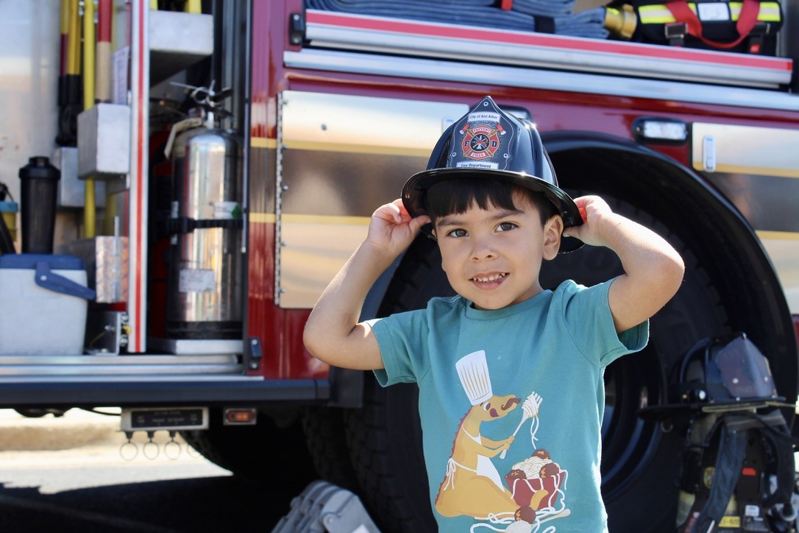
Sub-recipients, Partner Agencies and Recipient
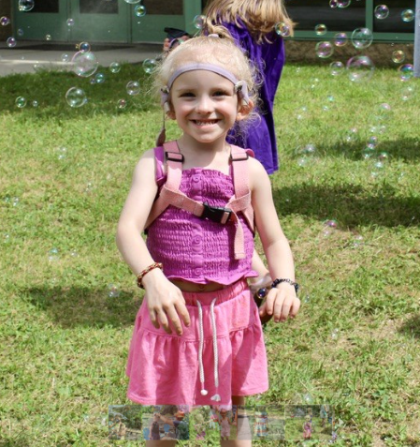
Washtenaw Intermediate School District’s Early Childhood Department supports four center-based sub-recipients/partner agencies and one home-based site throughout Washtenaw County. The center-based agencies provide classes Monday-Thursday offering full and half day programs for 427, 3 and 4-year-old children who lack access to quality resources within Washtenaw County. By blending 248 Head Start slots with State funded Great Start Readiness Program (GSRP) slots, agencies were able to make school-day programs available to 427 Head Start students. WISD’s Head Start program also has prenatal mothers, infants and toddlers using a home-based Early Head Start model. Using this model, women, infants, and toddlers receive home visits using the parent education curriculum Parents as Teachers (PAT). Home visits are provided weekly for a minimum of 90 minutes where developmental parenting is supported using a coaching approach to parent education. While allocation from Head Start allows WISD to serve 56 participants, through blending of state funding sources, Section 32p (4) Home Visiting adds an additional 9 eligible participants that can receive programming allowing WISD to serve 65 participants.

Locations
CENTER-BASED AGENCIES
Sub-recipient/Partner Agencies | Sites
Ann Arbor School District | Westerman Preschool & Family Center  2775 Boardwalk Street, Ann Arbor, MI 48104-6713  734-994-2303
Lincoln Consolidated Schools | Lincoln Early Childhood Center  8850 Whittaker Road, Ypsilanti, MI 48197  734-484-7070
Whitmore Lake Public Schools | Whitmore Lake Early Childhood Center  8845 Main Street, Whitmore Lake, MI 48189  734-449-4464
Ypsilanti Community Schools | Beatty Early Learning Center  1661 LeForge Road, Ypsilanti, MI 48198-9611  734-994-8178
Ford Early Learning Center
2440 East Clark Road, Ypsilanti, MI 48198-3362
734-221-1800
Perry Early Learning Center
550 Perry Street, Ypsilanti, MI 48197-5331
734-221-1700
HOMEBASED AGENCY
Washtenaw Intermediate School District – Early Childhood Department | WISD Early Head Start  1819 South Wagner Road, Ann Arbor, MI 48106-1406  734-994-8100

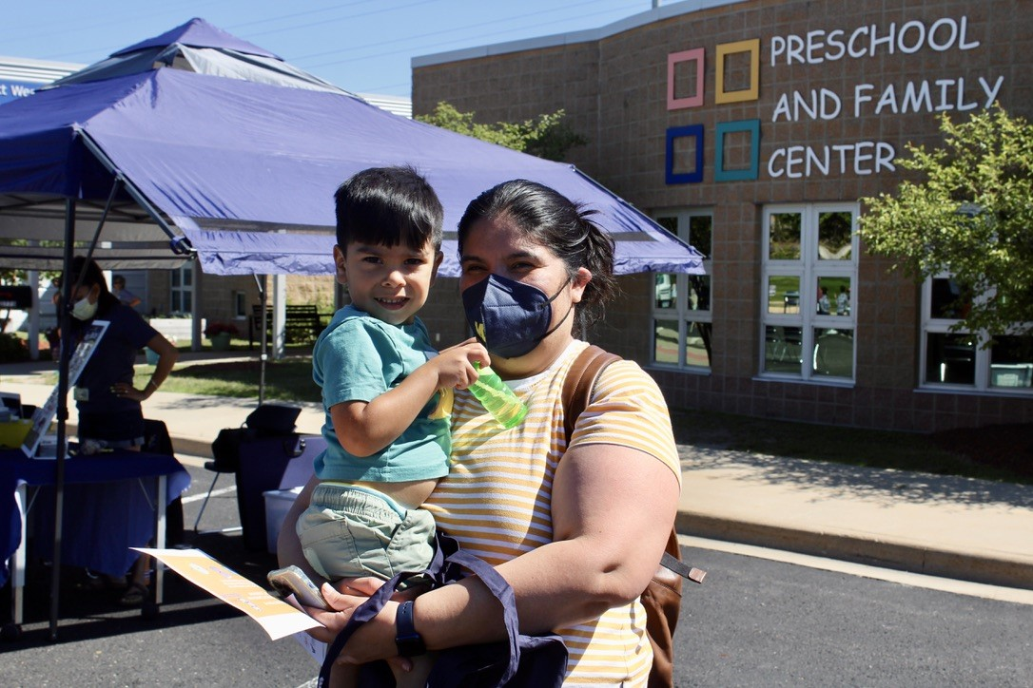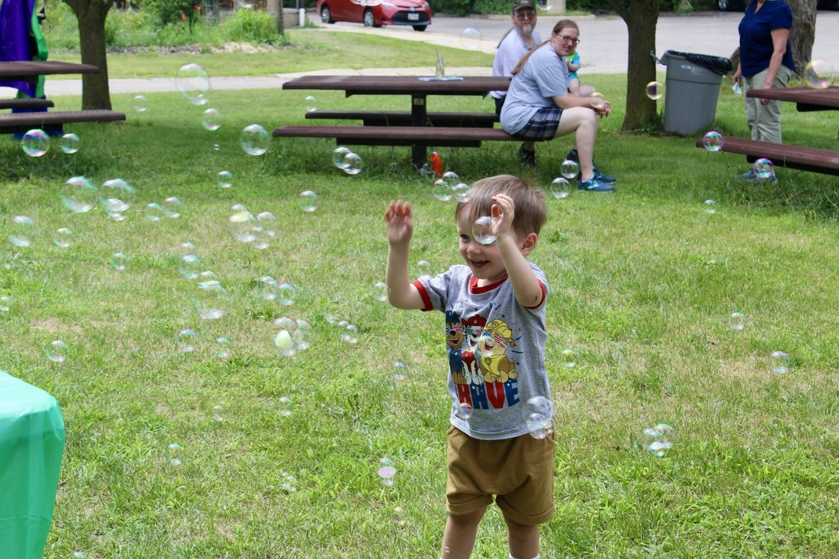

Grantee Budget

Early Childhood 2021-2022 Funding
Washtenaw ISD-supported early childhood programming exists within the nine cities of Washtenaw County. Four of the nine distinct districts currently offer center-based Head Start. Early Head Start services are provided in a home-based format and include socialization activities. As a result of the collaborative community partners and multiple funding streams, nine school districts and community-based organizations offer equitable services to over 2,000 children and families with the support of Washtenaw ISD.

Washtenaw ISD EC department funds programming for families and children prenatal-5 years of age. The State of Michigan-funded programs are Early On, 32p/32p (4)-Home Visiting, & Great Start Readiness Program (GSRP). Federal funds for Early On infant and toddler services, Early Head Start home-based and center-based Head Start preschool programs comprise the department’s funding. As a result, the children, and families of Washtenaw County benefit from a comprehensive array of services. The annual operating budget for FY 23 (School Year 22-23) is over $18,000,000.00.

Head Start and Early Head Start funding in Washtenaw County makes up approximately 1/3 of all funding for Washtenaw ISD Early Childhood Department. The chart below displays the operating budget. The percentage provides a visual display of the contribution for each funding source.

The fiscal strategic framework of the ISD uses an equitable, inclusive model that ensures children are ready and prepared for success in school and life.

The collective impact of funding sources allows the WISD to proactively address the diverse service needs of the county. Those needs are based on working collaboratively with district staff, collection and ongoing review of program data, the individual needs of children, district, and community at large.

Washtenaw ISD Early Childhood Department Budget Breakdown
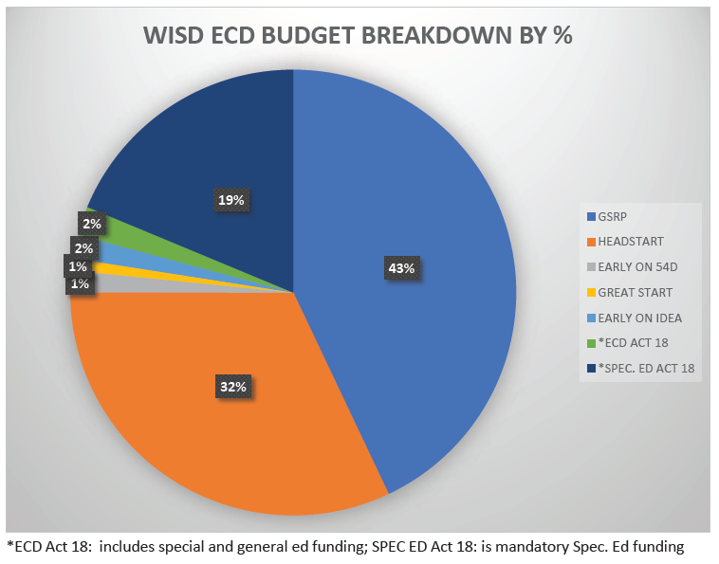
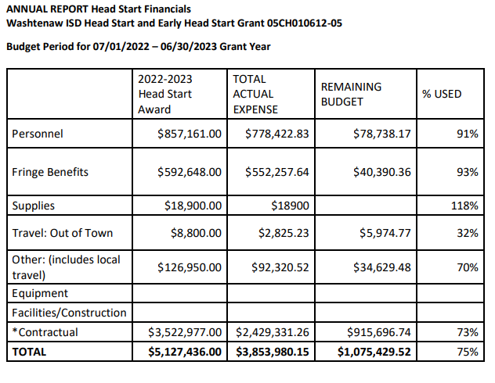
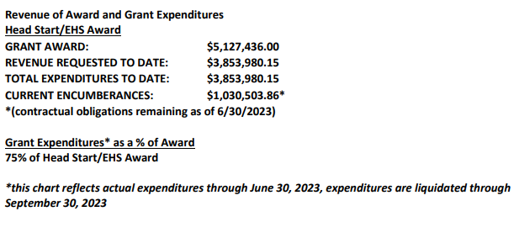

Recruitment
The purpose of recruitment is to increase the community’s awareness of WISD Childhood Programs to maximize the enrollment of children. The Head Start Program Performance Standards require specific efforts to actively locate and recruit children with disabilities and other vulnerable children, including homeless children and children in foster care. The goal of any recruitment process is to ensure full enrollment within our Head Start and Early Head Start programs. Recruitment is a year-round activity and does not stop when we hit full enrollment! We continue to recruit for the waitlist and for when children age out. Across our programs we have joined in more than 50 events across Washtenaw County.
We are in partnership with the WIC fresh program at farmer’s markets in Ann Arbor and Ypsilanti. Other events include Juneteenth events, back to school bashes, Jazz Fest, Touch-a-Truck, and library events. Other recruitment includes bus advertisements on the outside and inside of the bus, weekly social media ads, ads in newspapers, and we are currently working on a commercial with Detroit Public TV. Other efforts include flyers going out on pizza boxes, countless restaurants and businesses, book bundles to medical offices, local carnivals, and local parades.

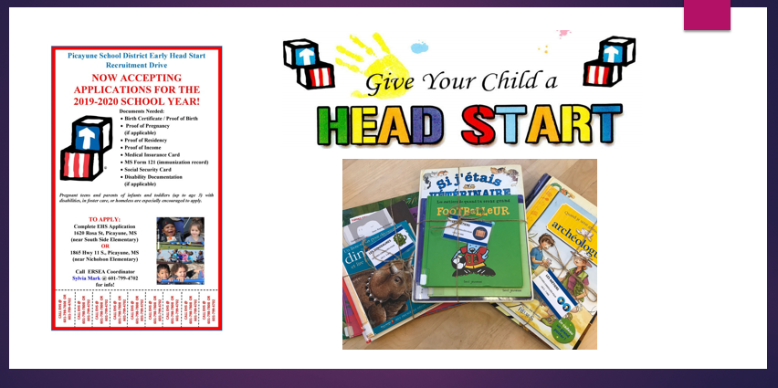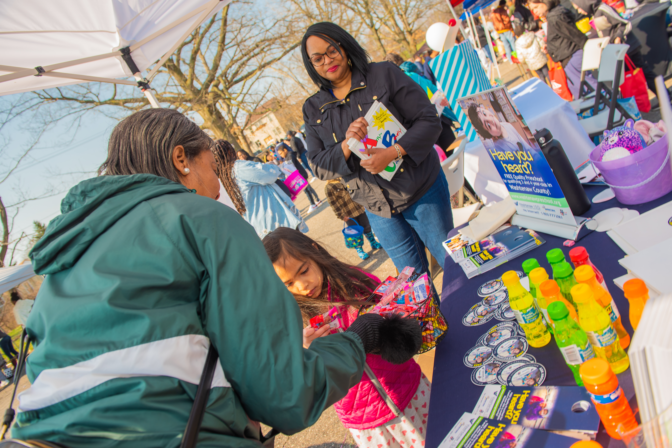

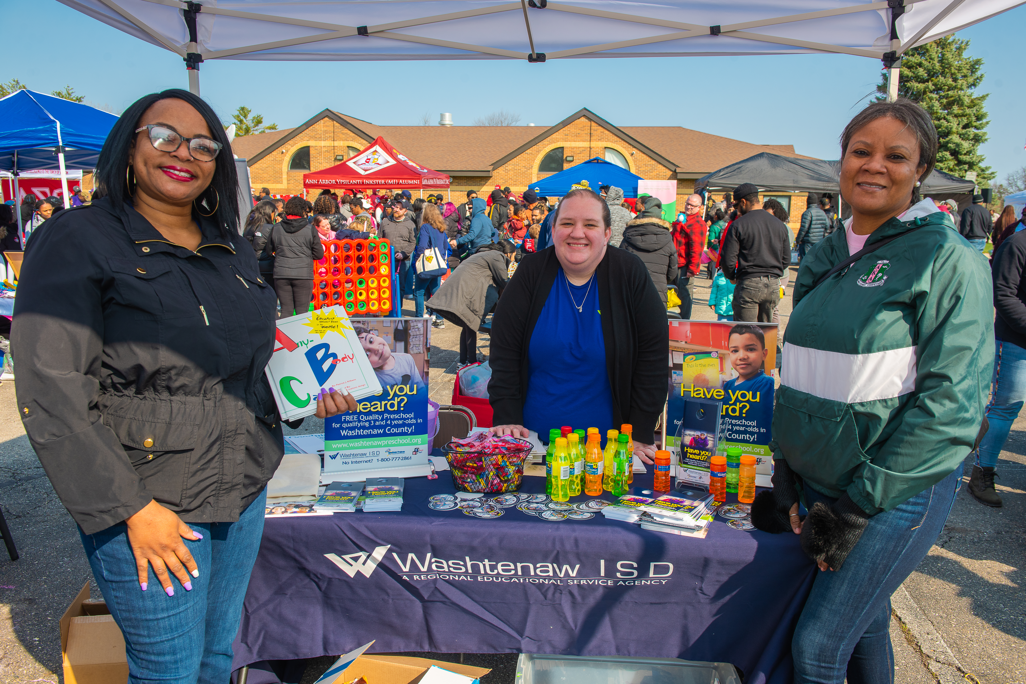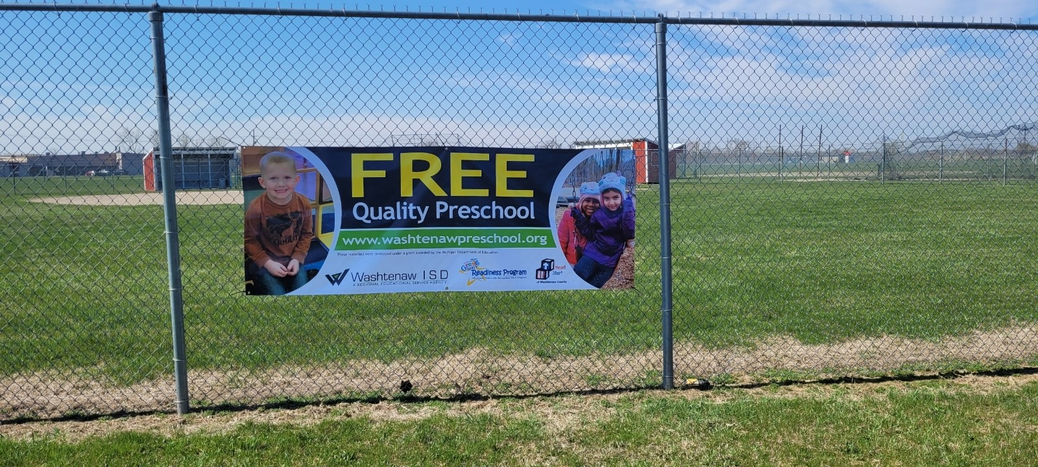

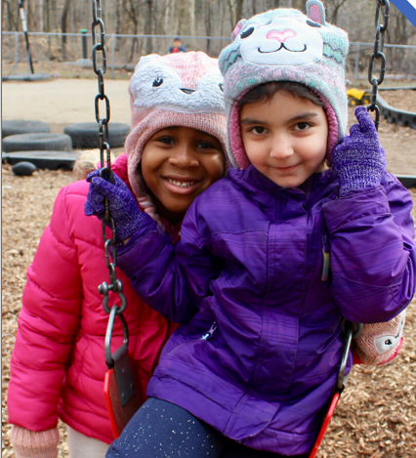
Enrollment

Percentages of Eligible Children Served and Services Provided

Enrollment PIR Performance Indicator | Head Start  # Enrolled | Head Start  % Total Enrollment | Early Head Start # Enrolled | Early Head Start % Total Enrollment
Total Funded Enrollment | 427 | N/A | 56 | N/A
Total Cumulative Enrollment – Children | 469 | 100% | 103 | 100%
Number of Children Enrolled <45 days | 15 | 3% | 10 | 10%
ENROLLMENT – CHILDREN BY AGE
Under 1 Year | N/A | N/A | 23 | 22%
1 Year Old | N/A | N/A | 28 | 27%
2 Years old | N/A | N/A | 24 | 23%
3 Years Old | 177 | 38% | 24 | 23%
4 Years Old | 281 | 60% | N/A | N/A
5 Years and Older | 11 | 2% | N/A | N/A
ENROLLMENT – PREGNANT WOMAN
Total Enrollment of Pregnant Women | N/A | N/A | 4 | 4%
ENROLLMENT BY ELIGIBILITY
Income Below 100% Poverty Line | 153 | 33% | 44 | 43%
Receipt of Public Assistance | 257 | 55% | 52 | 50%
Foster Child | 3 | <1% | 0 | 0%
Status as Homeless | 42 | 9% | 1 | <1%
Over-Income | 14 | 3% | 6 | 6%
ENROLLMENT BY ETHNICITY
Hispanic or Latino Origin | 57 | 12% | 16 | 16%
Non-Hispanic or Non-Latino Origin | 412 | 88% | 87 | 85%
ENROLLMENT BY RACE
American Indian or Alaska Native | 0 | 0% | 0 | 0%
Asian | 18 | 4% | 24 | 23%
Black or African American | 271 | 58% | 29 | 28%
Biracial/Multi-racial | 47 | 10% | 7 | 7%
White  Native Hawaiian/Pacific Islander | 131  2 | 28%  .4% | 43  0 | 42%  0%
ENROLLMENT BY HOME LANGUAGE
English | 370 | 79% | 48 | 46%
Spanish | 36 | 7% | 14 | 14%
Middle Eastern and South Asian Languages | 39 | 8% | 41 | 40%
East Asian Languages | 4 | <1% | 0 | 0%
European/Slavic Languages | 5 | 1% | 0 | 0%
African Languages | 15 | 3% | 0 | 0%
American Sign | 0 | 0% | 0 | 0%
1) Percentages based on cumulative number of enrolled children throughout the 2021-2022 program year.
2) Due to rounding percentages, each section combined percentages may be slightly greater or less than 100%.

Attendance
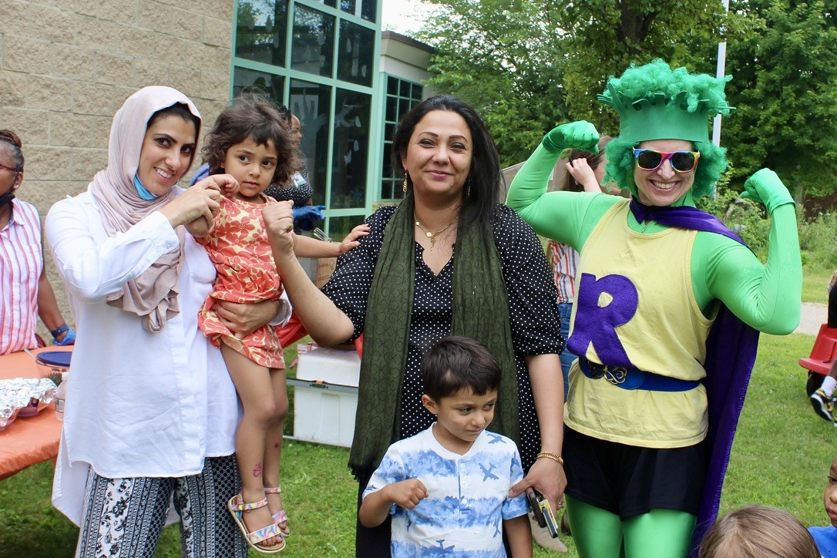
For the 2022-2023 program year, the WISD Head Start Grantee’s Average Daily Attendance was at 79.13% primarily due to program staff/child reported illnesses and transportation.

Nutrition
The WISD Head Start programs provide children with nutritious meals in an environment where children and program staff eat family-style, which promotes children to practice social and developmental skills while staff serve as positive role models. Classroom meals are funded by CACFP and cover 43,309 breakfasts; 43,429 lunches; and 43,379 snacks. Through a community partnership with the National Kidney Foundations children can participate in a 10-week nutrition, physical activity, and oral health program where children travel with Regie, the broccoli superhero, to different islands based on the colors of the rainbow and introduced to fruits and vegetables from these islands.

Health
Head Start and Early Head Start staff were persistent in working with families to increase the percentage of children with medical homes, health insurance, and up to date immunizations. These numbers were exemplary with percentages over 88%. The percentage of children with dental homes has significantly improved this program year with percentages reaching 84%. We strive to ensure all children have access to appropriate medical and dental care with the goal of having healthy children ready for school and ready to learn.
Health PIR Performance Indicator | Head Start  # Enrolled | Head Start  % Total Enrollment | Early Head Start # Enrolled | Early Head Start % Total Enrollment
Children with health insurance | 465 | 99% | 97 | 94%
Number Enrolled in Medicaid and/or CHIP | 440 | 93% | 97 | 94%
Number with Private Insurance | 25 | 5% | 0 | 0%
No Insurance | 4 | <1% | 2 | 2%
MEDICAL HOME
Children with a medical home | 440 | 94% | 99 | 96%
MEDICAL SERVICES
Children up to date on EPSDT | 390 | 83% | 11 | 11%
Children with a chronic health condition needing treatment | 30 | 6% | 6 | 6%
Of these, the number who have received treatment | 30 | 6% | 6 | 6%
IMMUNIZATION SERVICES
Children up to date | 412 | 88% | 51 | 50%
Children to have received all immunizations possible currently, but who have not received all immunizations for their age | 5 | 1% | 30 | 29%
Number of children exempt | 35 | 7% | 2 | 0%
DENTAL HOME
Children with a dental home | 394 | 84% | 81 | 79%
EHS children who received oral health care | N/A | N/A | 10 | 10%
HS Children who received professional dental exam | 361 | 77% | N/A | N/A
Number of children in need of treatment | 22 | 5% | N/A | N/A
Number of children who received treatment | 19 | 4% | N/A | N/A
3) Numbers based on cumulative number of enrolled children at end of enrollment from the PIR.

Pregnant Women – Health Services |  |  | Early Head Start # Enrolled | Early Head Start % Total Enrollment
Total Cumulative Enrollment – pregnant women |  |  | 4 | N/A
Number of pregnant women with at least one type of health insurance |  |  | 4 | 100%
Pregnant Women – Services
Prenatal Care |  |  | 4 | 100%
Postpartum Care |  |  | 1 | 25%
Mental Health Intervention and Follow-up |  |  | 0 | 0%
Education on infant care and sleep practices |  |  | 4 | 100%
Substance abuse treatment |  |  | 0 | 0%
Prenatal education on fetal development |  |  | 3 | 75%
Information on the benefits of breastfeeding |  |  | 3 | 75%
Number of pregnant women who received a professional dental exam and/or treatment |  |  | 3 | 75%

Family Information
Family Service PIR Performance Indicator | Head Start  # Enrolled | Head Start  % Total Enrollment | Early Head Start # Enrolled | Early Head Start % Total Enrollment
Total Number of Families | 438 | N/A | 82 | N/A
Number of Single Parent Families | 290 | 66% | 29 | 28%
Number of Two Parent Families | 148 | 34% | 53 | 51%
FAMILY SERVICES
Number of families who received services:
Emergency/Crisis Intervention | 139 | 30% | 17 | 16%
Housing Assistance | 74 | 16% | 5 | 5%
Asset building services | 87 | 19% | 3 | 3%
Mental Health Services | 78 | 17% | 4 | 4%
ESL Training | 71 | 15% | 33 | 32%
Assistance enrolling in education/job training prog. | 55 | 12% | 3 | 3%
Substance Misuse Prevention/Treatment | 1 | <1% | 0 | 0%
Education on preventive medical and oral health | 126 | 27% | 72 | 70%
Research-based parenting curriculum | 107 | 23% | 55 | 53%
Education on relationship/marriage | 6 | 1% | 2 | 2%
Assistance to Families of Incarcerated Individuals | 7 | 1% | 0 | 0%
Number of families that received at least one service | 223 | 47% | 73 | 71%
4) Numbers based on the cumulative number of enrolled families at end of enrollment from the PIR.

Parent Involvement & Family Engagement
Washtenaw ISD Head Start Home-Based and Center Based Programs
Parents are invited to serve on the Policy Council and Parent Committees. These parents or family members serve as advocates for children and as ambassadors for the Head Start program. Our Policy Council Chair is a father who has been very involved in his child’s education and is the Chair of his programs policy committee.

This year our programs started off with a terrific opportunity for involvement we offered Dads & Donuts, Moms, and Muffins the turnout was excellent we wanted to find a way to incorporate both parents in the program and to allow guardians and caregivers to participate as well. Both Early Head Start and Head Start offer families many opportunities to be involved in their child’s learning to increase their knowledge of child development and to support their role as their child’s first and best teacher.

Our parents and staff had the opportunity to attend the National Head Start Parent and Family Engagement Conference held in Dallas, Texas December12-15, 2022. The Conference focused on how Head Start parents, families, and staff can best partner to promote both family engagement and children’s development. The conference also explored a wide range of new resources and thinking on the forefront topics of early childhood development and how Head Start programs can address the needs of children, families, and staff.

Community Engagement
Our programs work to partner with community agencies and support families to connect with these partners, as needed. Likewise, Washtenaw ISD works to maintain connections to community.
agencies to benefit our children and families.

During the 2022-2023 school year, our community partners provided a variety of services to
children and families including:
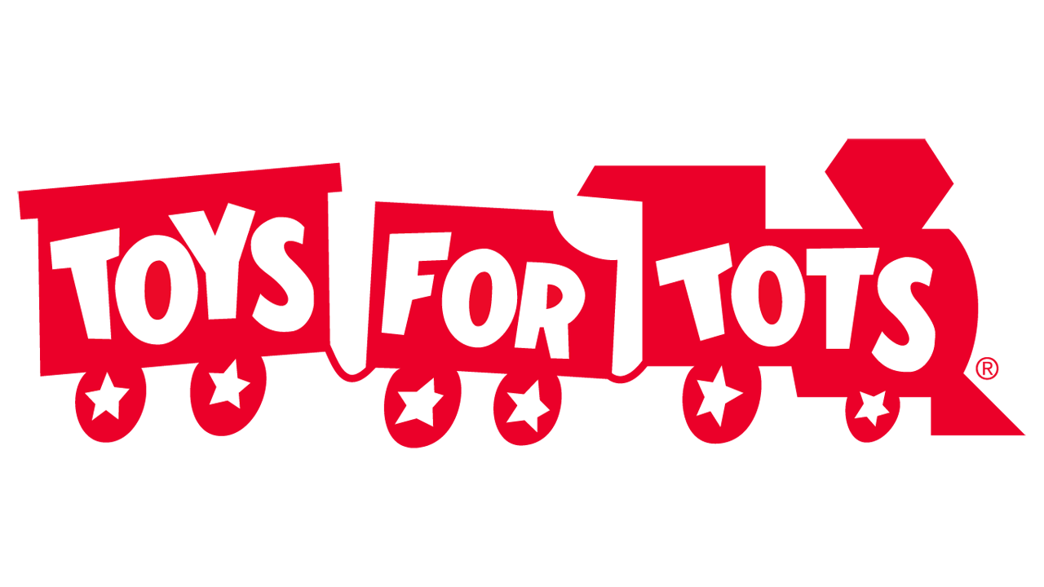
Toys for Tots- Provided all our families with toys for the Christmas Holiday, the intent was that none of our preschool go without something for Christmas. This partnership continues to be valuable to EHS/HS to ensure all our children receive something during the holiday season.
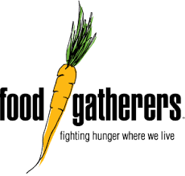
Food Gathers - Our partnership with food gatherers was a huge help to our families, supplemental food was given out for families who were experiencing food insecurities. They also provided household items, personal care items, and cleaning supplies.
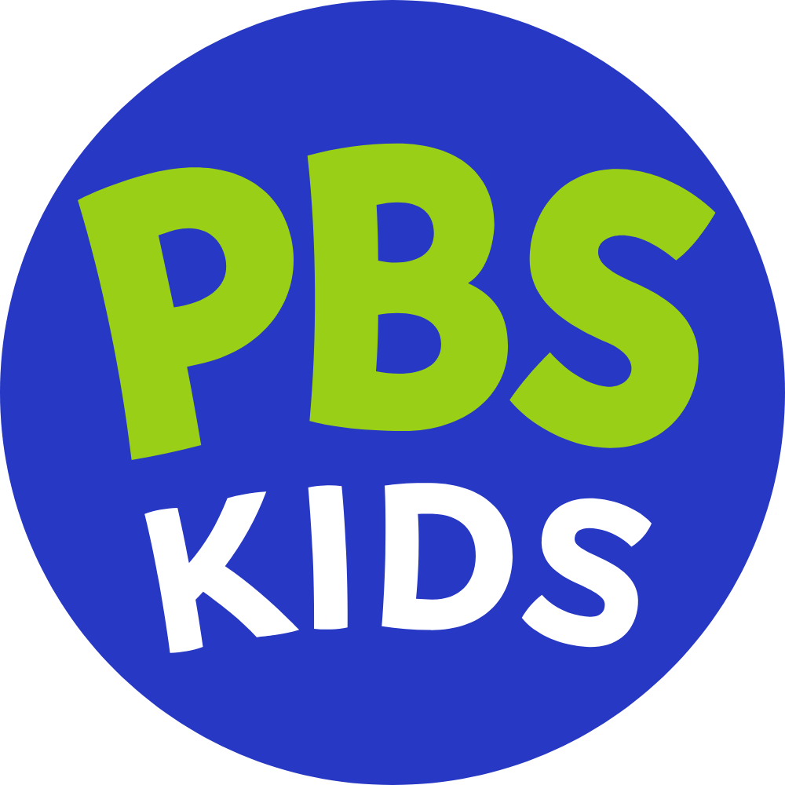
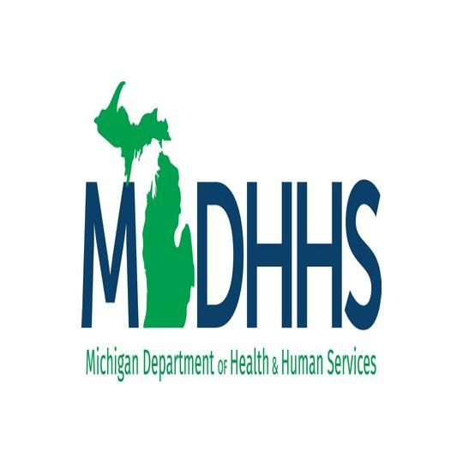
PBS Kids- Early Childhood Team Offered Virtual Parent Meet Ups, for Parents and Guardians via Zoom these meetings occurred the 2nd Thursday of each month for children 0-8 years old. The focus of the workshops was for parents to learn how to start early, making learning fun and exciting for your child.

Washtenaw County Department of Health and Human Services- provided help to families with children, for food and toy distribution during the holiday assistance for families in need.
Home Base- Early Head Start
Celebration of families- We celebrated the culture and diversity of the families in our program. We connected with food, music, and dancing.
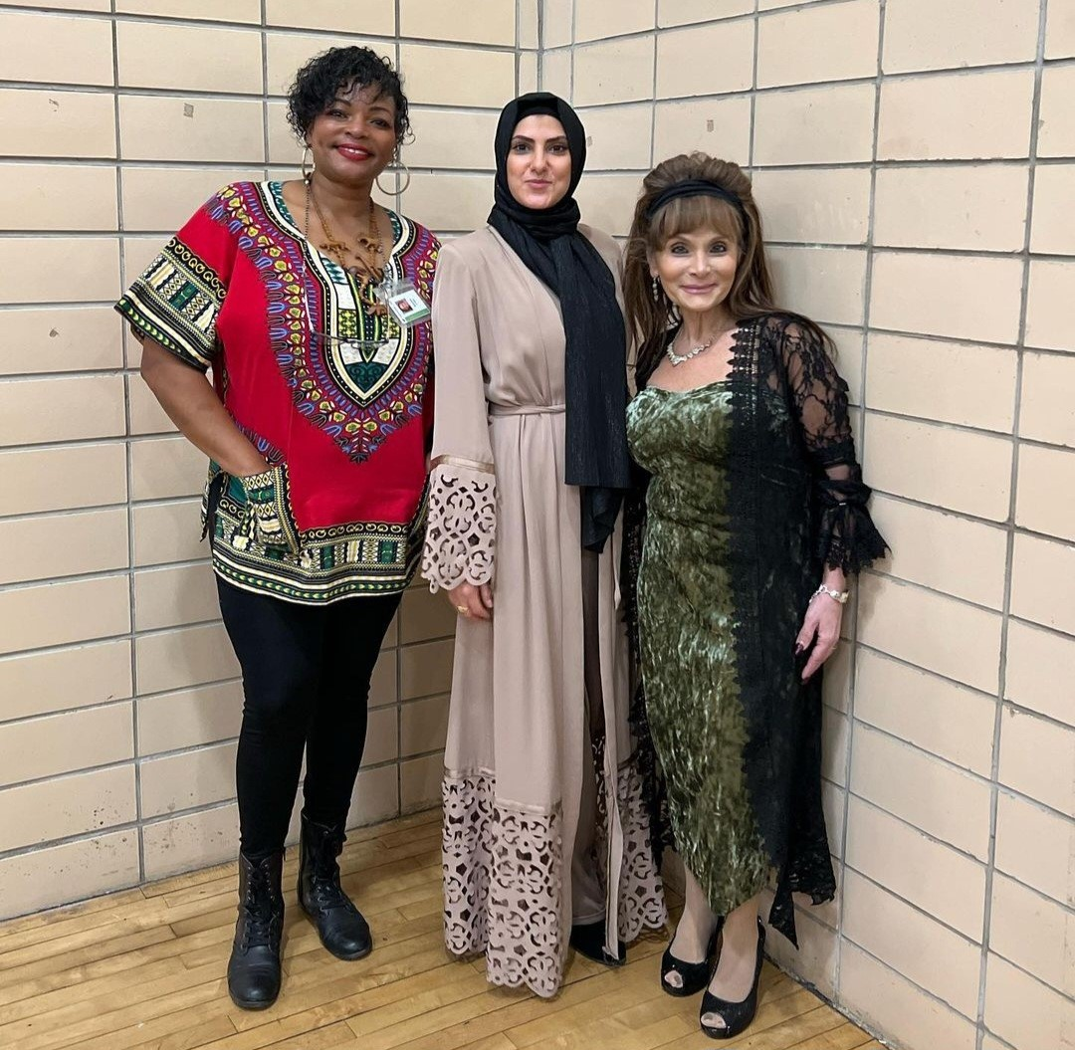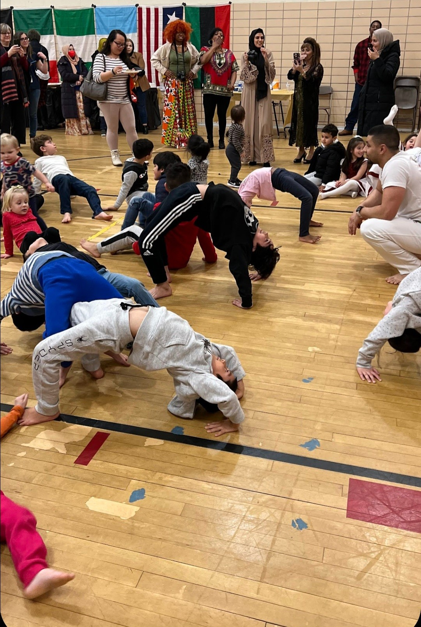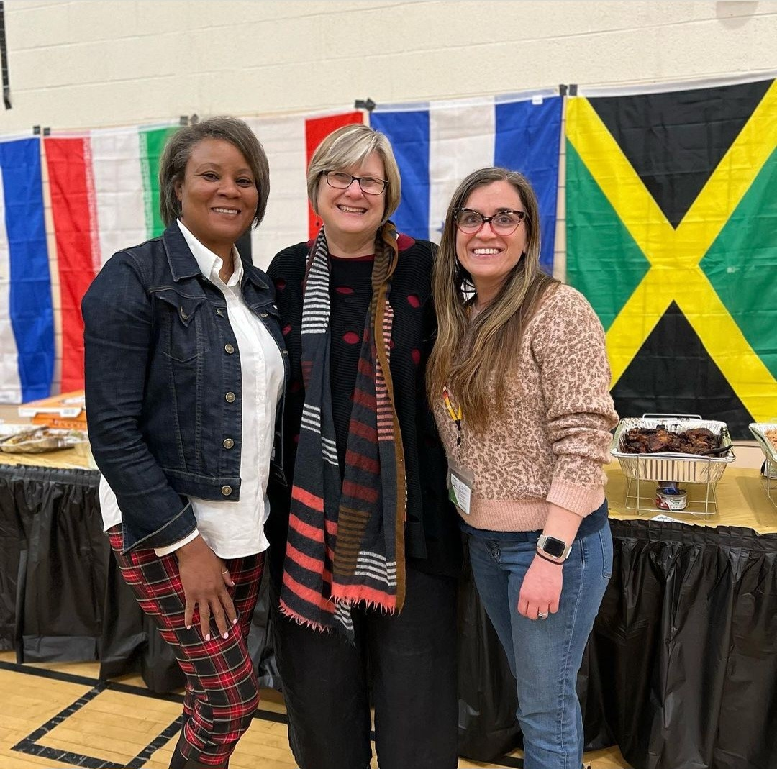

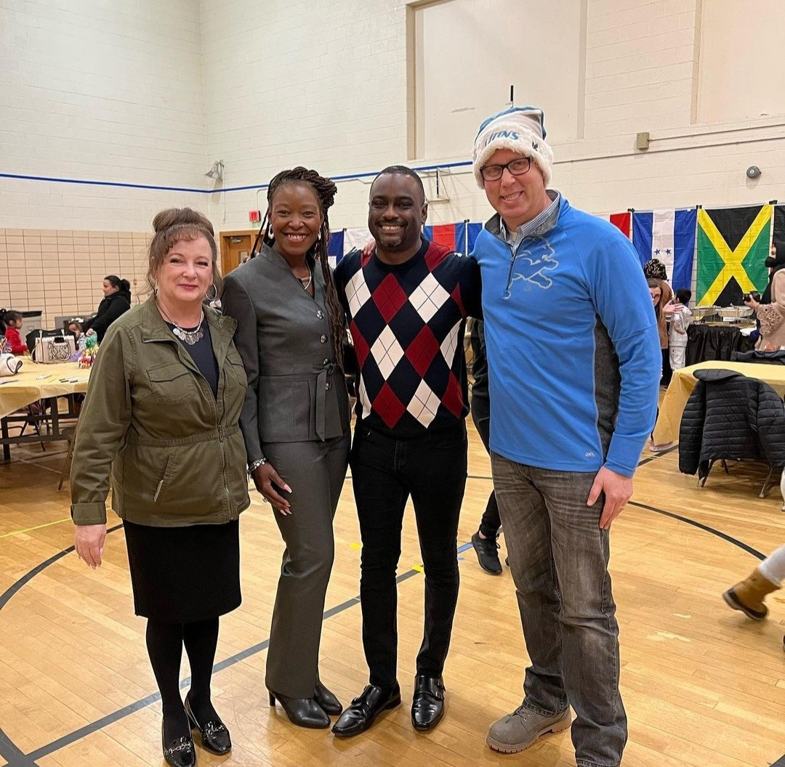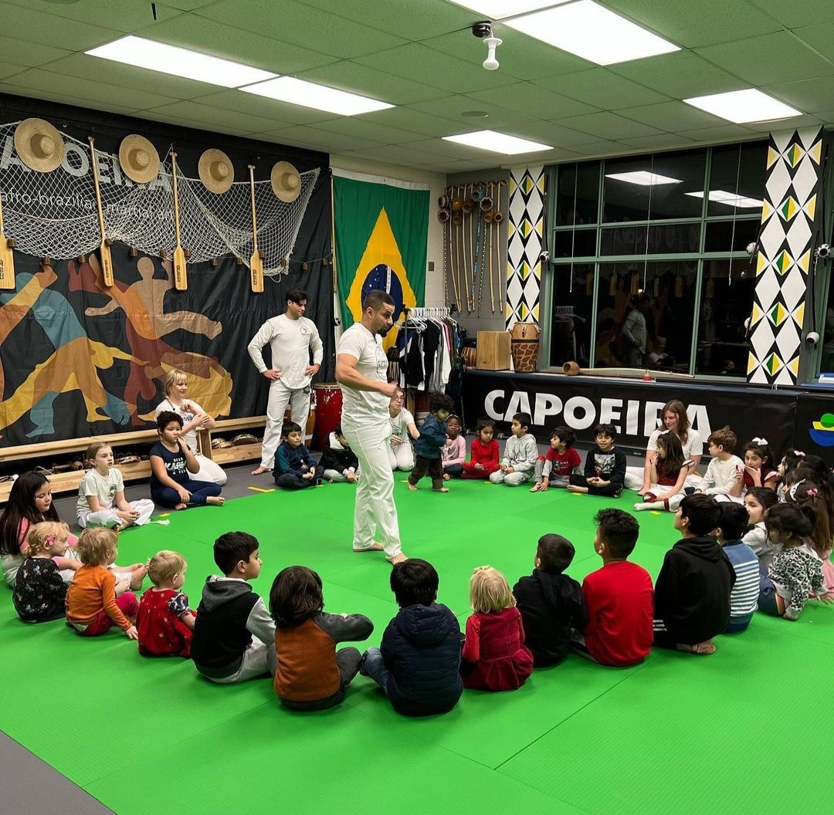

Annual Ice Cream Social- is a way to welcome new families into the program and to say goodbye to those transitioning to preschool.

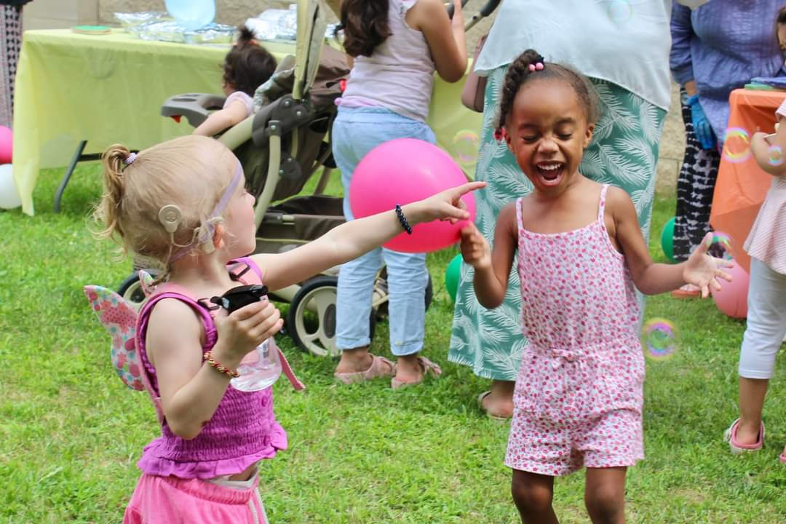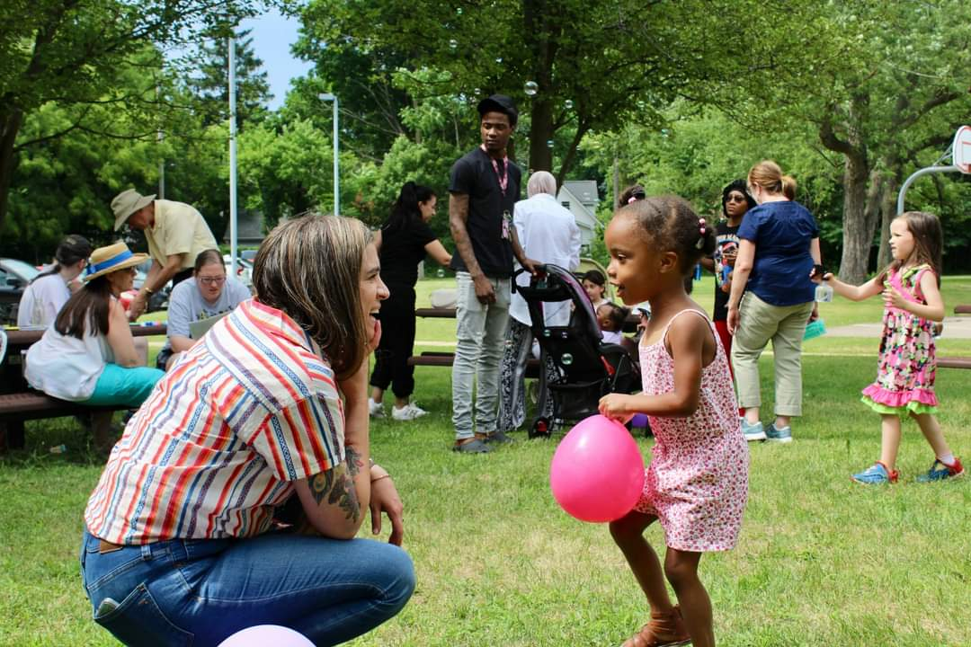
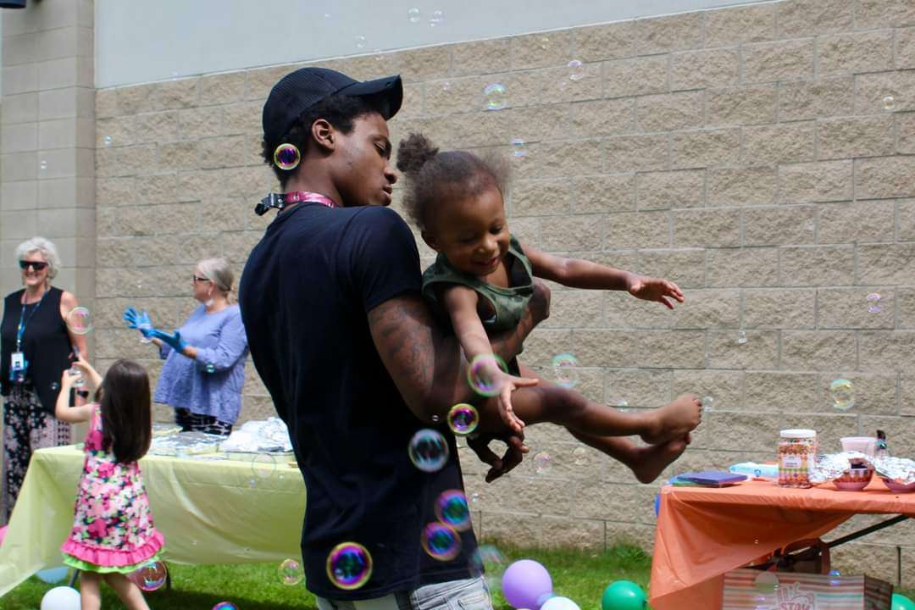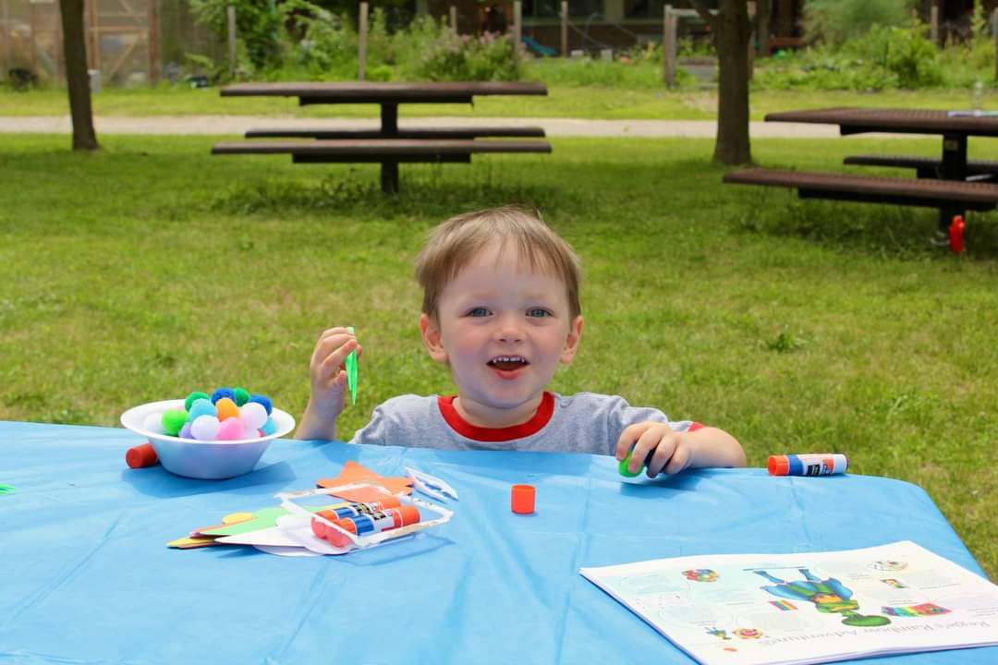

Pop-Up Safety Town- Safety and injury prevention programs are held twice a year for Head Start families. This year Pop-Up Safety town was held on 4/13/23 at Perry and 5/10/23 at Lincoln.
Sponsored by the University of Michigan and AAA Auto Club Group

Pop-up safety towns are free family events that feature different stations attendees can visit that provide injury prevention education and methods on bike helmets, car seats, dog bite prevention, medication safety and pedestrian safety. The stations are created to look like different buildings one would find in a town. Children who attend the events leave with adjustable bike helmets and a free book.
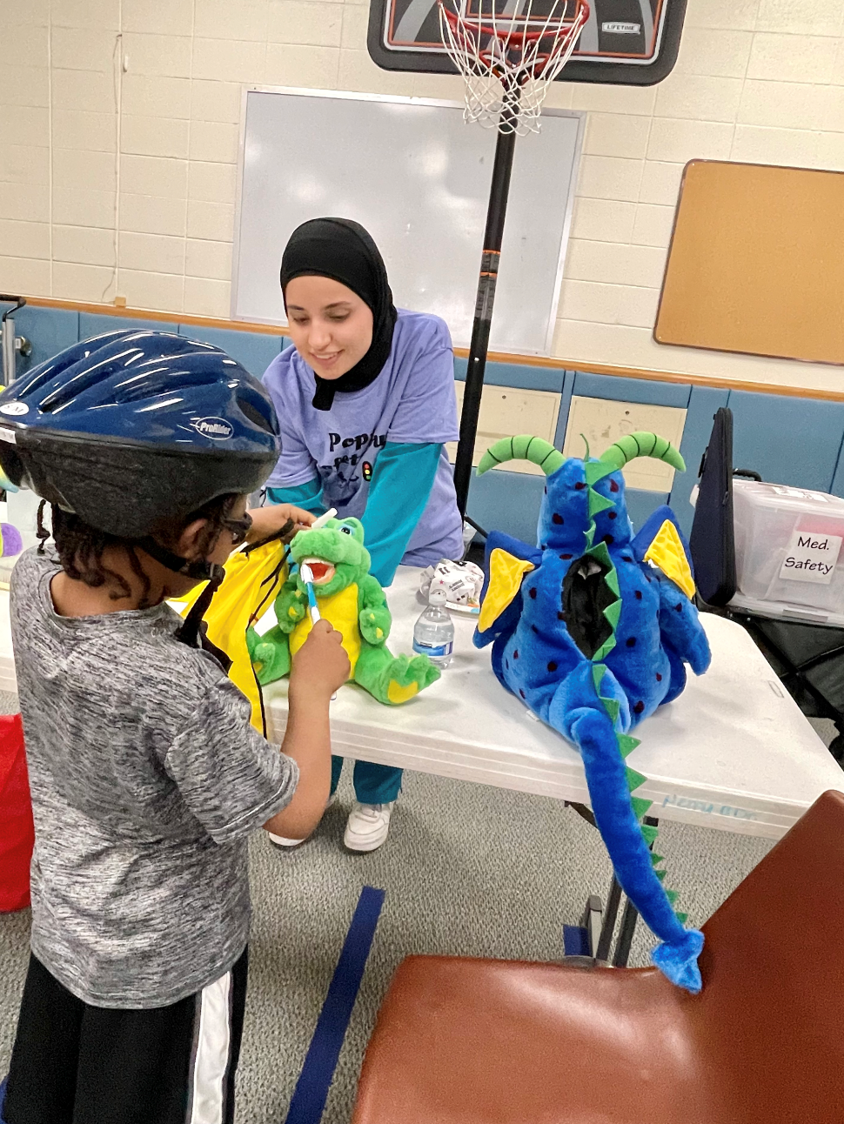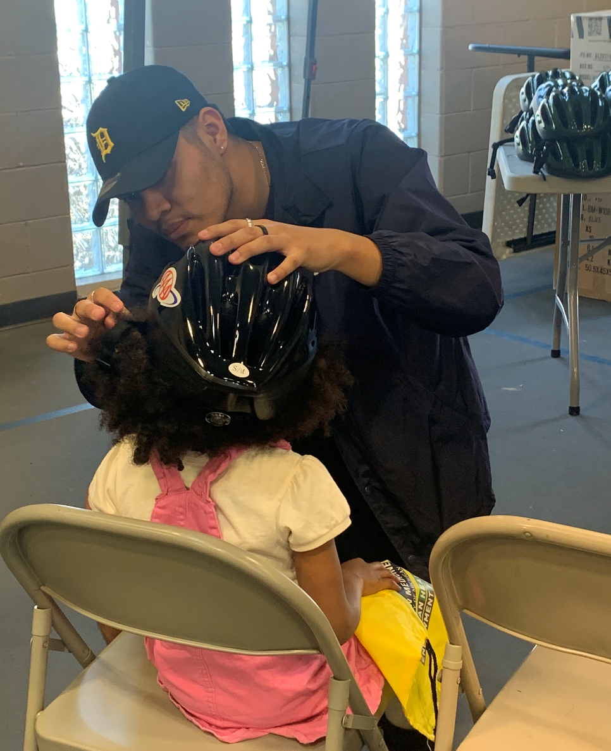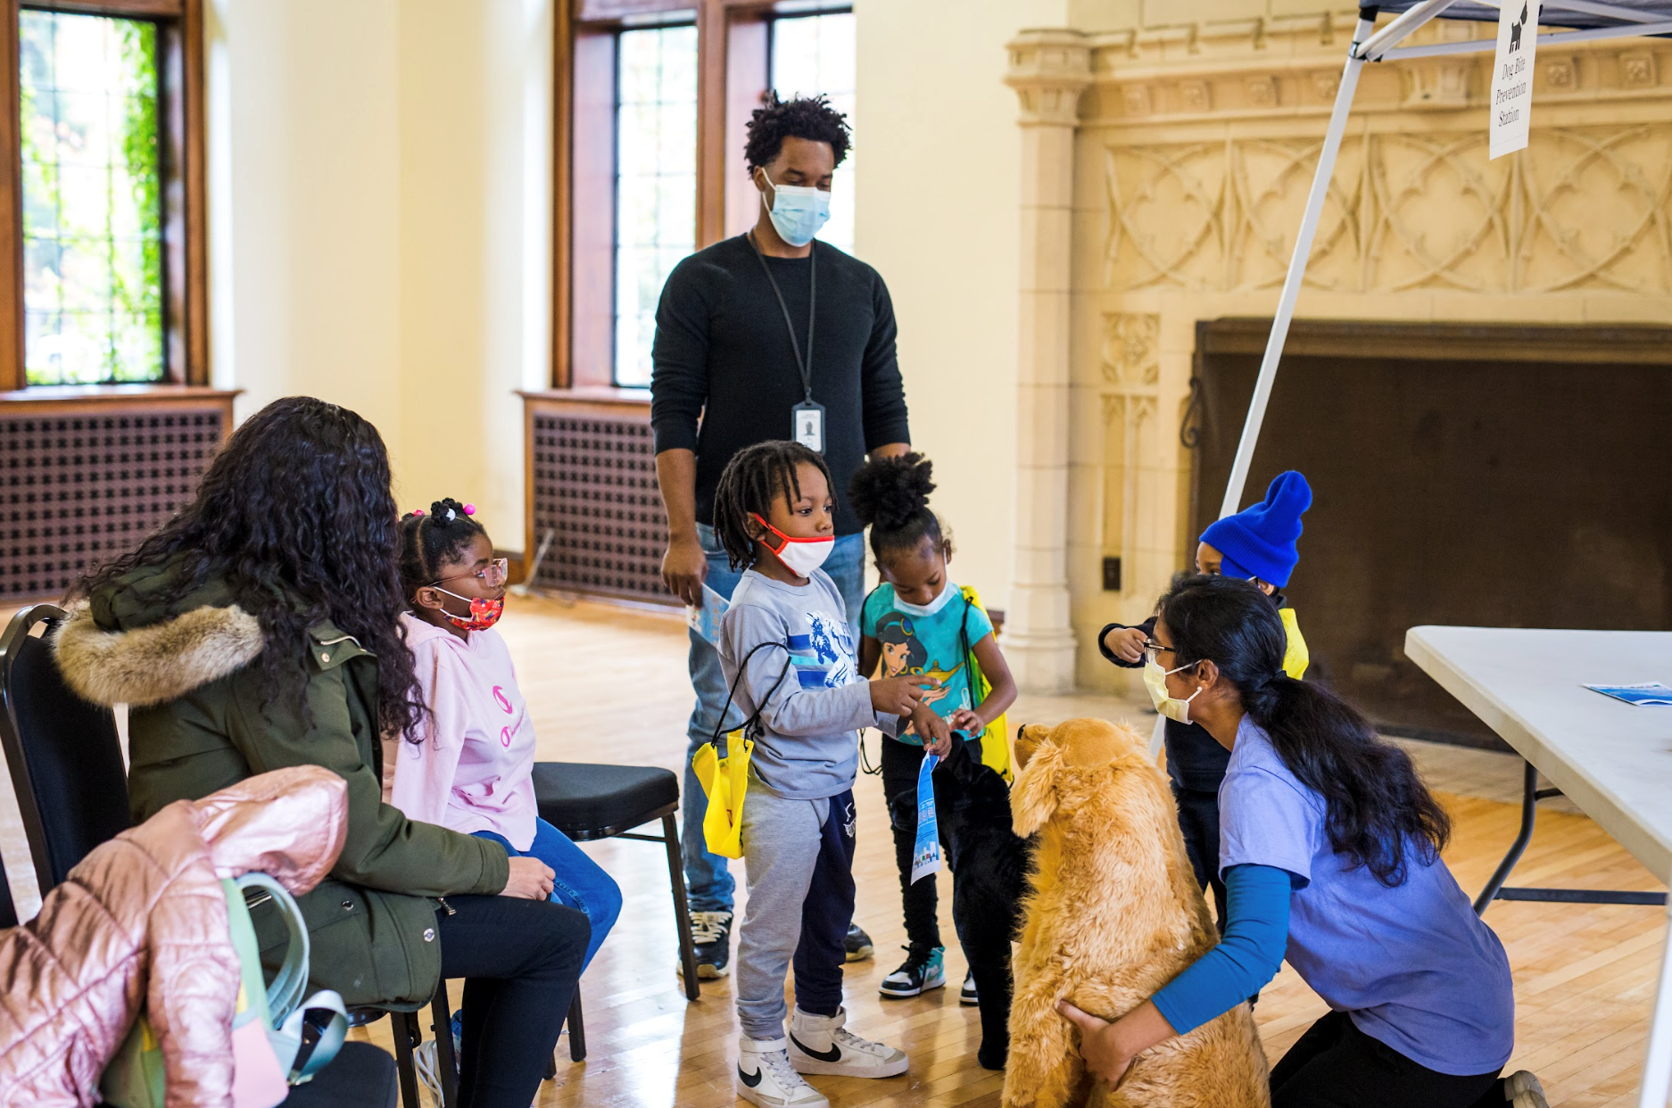

Disability and Mental Health Services
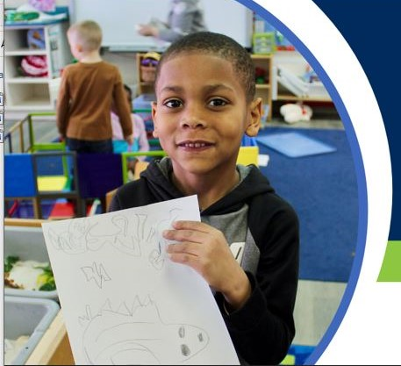
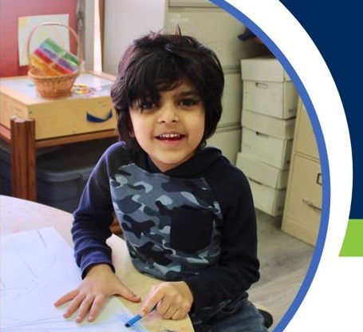
Sub-recipient agencies support the inclusion of children with disabilities in everyday programming. This inclusive experience is beneficial for all children and fosters confidence and positive self-esteem. Mental Health services are provided in collaboration with the Grantee Behavioral Health Specialist and staff at the sub-recipient sites. The recipient uses a tiered conceptual framework of evidence-based practices for promoting healthy social and emotional development and to increase mental health awareness, promotion, and prevention.
Disability Service PIR Performance Indicator | Head Start  # Enrolled | Head Start  % Total Enrollment | Early Head Start # Enrolled | Early Head Start % Total Enrollment
Number of children enrolled who have an Individualized Family Service Plan (IFSP) indicating they have been determined eligible by the Part C Agency to receive early intervention services under the Individuals with Disabilities Education Act (IDEA) | N/A | N/A | 6 | <1%
Number of children enrolled who have an Individualized Education Program (IEP) indicating they have been determined eligible by the LEA to receive special education and related services | 60 | 13% | N/A | N/A

Education – Supporting High Quality Preschool Classrooms
Classroom Assessment Scoring System (CLASS)
High quality adult child interactions are at the heart of the work that we do in preschool classrooms as they build the foundation for learning, both during the preschool years and in a child’s later education. The CLASS® tool is utilized in all our classrooms to look deeply at these interactions. The tool has 10 dimensions of teacher-child interactions rated on a 7-point scale. (Note: The Negative Climate dimension is reverse scored) The 10 CLASS® dimensions are organized into three domains: Emotional Support, Classroom Organization, and Instructional Support.

All classrooms have CLASS observations conducted at least once a year. Data from these observations is used to support individual teaching teams, focusing on their many strengths, and building goals around areas that need improvement. Site and county-wide data is used to plan professional development in the coming year, including our yearly conference for teachers and other program staff.
 |  |  | Head Start Nat’l  Average 2020 | HS Quality Thresholds | HS Competitive Thresholds | Wash. Co.  Spring 2023
The degree to which teachers establish & promote a positive climate in their classrooms through their everyday interactions. | Emotional  Support |  | 6.03 | 6.00 | 5.00 | 6.69
 |  | Positive Climate | 5.98 |  |  | 6.84
 |  | Negative Climate | 1.09 |  |  | 1.20
 |  | Teacher Sensitivity | 5.88 |  |  | 6.53
 |  | Regard for Student Perspectives | 5.33 |  |  | 6.58
Classroom routines & procedures that help with children’s behavior, time & attention in the class. | Classroom  Organization |  | 5.78 | 6.00 | 5.00 | 6.28
 |  | Behavior  Management | 5.96 |  |  | 6.31
 |  | Productivity | 6.07 |  |  | 6.60
 |  | Instructional Learning Format | 5.32 |  |  | 5.94
The ways that teacher use the curriculum and interact to promote cognitive and language dev. | Instructional  Support |  | 2.94 | 3.00 | 2.3 | 4.45
 |  | Concept Development | 2.46 |  |  | 3.90
 |  | Quality of Feedback | 2.90 |  |  | 4.27
 |  | Language Modeling | 3.45 |  |  | 5.17
WASHTENAW COUNTY CLASS DATA COMPARED TO NATIONAL AVERAGES

School Readiness Goals
School Readiness Goals, established at the county level and reviewed yearly allow us to have common objectives and ensure that we are working toward preparing all children for kindergarten and beyond. The data below is being reported for all sites in Washtenaw County who receive Head Start funding. Percentages include all children who have sufficient data to be able to report on the benchmarks for each area.
APPROACHES TO LEARNING
THE MANNER IN WHICH A CHILD WORKS WITH OTHERS AND APPROACHES TASKS AND LEARNING LEADS TO THE DEVELOPMENT OF CRITICAL EXECUTIVE SKILLS FOR SCHOOL AND LIFE
% Of children above or meeting national average in this area:  Fall Winter Spring  51% 74% 74% | Goals we have for children in Approaches to Learning:  A child displays initiative and curiosity in their work and play.  A child is persistent in task and focused on their work or play.  A child works cooperatively with others.  A child expresses feelings, thoughts, and learning through exploring and actively participating in the creative arts.
SOCIAL AND EMOTIONAL DEVELOPMENT
H HOW A CHILD FORMS RELATIONSHIPS, REGULATES AND EXPRESSED EMOTIONS, AND DEVELOPS THEIR Personality ARE CORE COMPONENTS TO KINDERGARTEN READINESS
% of children above or meeting national average in this area:  Fall Winter Spring  59% 62% 64% | Goals we have for children in Social and Emotional Development:  A child forms healthy and secure relationships with peers and adults.  A child recognizes, expresses, and manages emotions in a positive manner.  A child adjusts to transitions between activities without major disruptions.  A child exhibits self-confidence in classroom learning and social interactions
COGNITION AND GENERAL KNOWLEDGE
THESE SKILLS HELP YOUNG CHILDREN DEVELOP BOTH LOGICAL AND ABSTRACT THINKING ATTRIBUTES AS WELL AS TO NURTURE ANALYTICAL THOUGHT
% Of children above or meeting national average in this area:  Fall Winter Spring  58% 78% 67% | Goals we have for children in Cognition and General Knowledge:  A child analyzes problems and develops solutions from their knowledge and past experiences.  A child demonstrates early math skills in the areas of counting, comparing, matching, sorting, measuring, and basic shapes.  A child observes & discusses living things and the natural world.  A child understands family and community roles and respects differences.
LANGUAGE AND LITERACY
EARLY LITERACY AND LANGUAGE DEVELOPMENT SERVE AS THE FOUNDATION FOR SCHOOL SUCCESS, THEY ARE THE KEY TO COMMUNICATION AND INTERACTIONS WHICH ASSIST LEARNING ACROSS ALL CHILD DEVELOPMENT DOMAINS
% Of children above or meeting national average in this area:  Fall Winter Spring  62% 56% 54% | Goals we have for children in Language and Literacy:  A child demonstrates early literacy skills including alphabet knowledge, storytelling, letter/sounds, phonemic awareness, & book knowledge.  A child expresses emotions, ideas, and needs via conversations with peers and adults using an increasingly varied vocabulary.  A child uses effective listening skills.  A child uses written shapes, symbols, pictures, letters, & simple words to convey thoughts and meaning.
PHYSICAL WELL-BEING AND MOTOR DEVELOPMENT
PHYSICAL WELL-BEING AND MOTOR DEVELOPMENT IMPACT A CHILD’S READINESS TO LEARN
% Of children above or meeting national average in this area:  Fall Winter Spring  70% 71% 66% | Goals we have for children in Physical Well-Being & Motor Development  A child’s growth and height status are developing on an age-appropriate scale.  A child displays basic gross motor skills in a wide range of physical activities involving movement.  A child demonstrates fine motor strength and coordination.  A child understands healthy choices in nutrition, health, & personal safety.

Celebrating our Successes and Moving Forward Together
The WISD Early Childhood Education team provided professional development throughout the 2022-2023 school year, including an annual conference and monthly opportunities. Featuring content that ranged from curriculum to health to connecting with families, this conference was attended by teachers, directors, family support and other staff from across the county.

To support programs in maintaining quality learning environments for children, WISD Early Childhood Education Team members continued the use of the Practice Based Coaching model. We also used the CLASS tool, described above, to look at the quality of teacher-child interactions in the classrooms and support teachers in making meaningful changes to enhance the learning and development of preschool children. Average CLASS scores for the preschool classrooms observed throughout Washtenaw County in 2022-2023 exceeded the Head Start National Averages from 2020 in all three major areas or domains- Emotional Support, Classroom Organization, and Instructional Support. WISD Education staff continued to use the CLASS framework in our support and coaching of teachers as well as in professional development provided to education staff.

All classrooms supported by Washtenaw ISD Head Start funding, utilizing the High Scope curriculum and the associated child assessment tool, COR-A. Teachers observe children, enter anecdotes, and plan for individualized activities and instruction based on that information. The High Scope curriculum is play-based and has a solid research base. Our teachers are supported in the use of the Plan-Do-Review sequence and the incorporation of the 5 Ingredients of Active Learning (materials, manipulation, choice, child thought & language, and adult scaffolding) into their daily routine.

Professional Development
Provider | Topic
Recipient Wide | - Entrance meeting  - ChildPlus Training  - Teacher and Home Visiting Coaching  - Pedestrian Safety training  - Conscious Discipline 101  - Why your EQ Matters Just as Much as Your IQ  - Bilingual and Bicultural: A Walk In Someone Else’s Shoes  - You Belong Here: Inclusive Practices to Support Every Child’s Development  - Mindfulness  - The DECA and You  - The Power of Play  - Wondering and Response Wheel & Balanced Caregiving  - Parent, Family, Community Engagement Framework 2.0  - Put On Your Ruby Red Resilience Slippers  - Preschool Beyond Walls: Moving Toward a Nature Based Approach  - Integrating Nature into Your Indoor Environment  - Teaching Strategies Lesson Plans & Studies & Digital Resources, Oh my!  - High Scope Lesson Plans  - Invitations to Writing  - Perfecting Planning Time  - Building Connections with Families  - Fun with Small Group Time  - Early Literacy and Read Aloud  - ERSEA Training  - Myths and Legends of High Scope  - Individualizing Support to Children and Families  - Resources and Answers to the Parenting Questions Teachers Get  - Supporting Children’s Transition to Kindergarten  - Understanding e-DECA  - Building Resilience During Uncertainty  - Self-Care During Resiliency

New Staff Orientation
From August 2022 – April 2023 seven (7) New Staff Orientations were held. New Staff Orientations were not held in September 2022 due to technical issues and in December 2022 due to inclement weather. In May 2023 orientation was not scheduled in alignment with program request. 42 staff registered to attend the New Staff Orientation. 34 staff attended a New Staff Orientation during the 2022-2023 program year. While there was an increase in the number of new staff due to staff turnover, staff shortages prevented several new staff from attending the 2022-2023 New Staff Orientation.

Position | Number of Attendees | Recipient | Sub-recipient
Program Directors | 1 | 0 | 1
Administrative/Secretarial | 0 | 0 | 0
Early Head Start Home Visitors | 2 | 1 | 1
Early Childhood Specialist | 1 | 1 | 0
Teachers | 10 | 0 | 10
Teacher Assistants – Associate Teachers | 18 | 0 | 18
Classroom Aides | 0 | 0 | 0
Content Area Specialist | 1 | 1 | 0
Policy Council/ Board Members | 2 | 2 | 0
*Partner staff are listed under Recipient

The Pajama Program
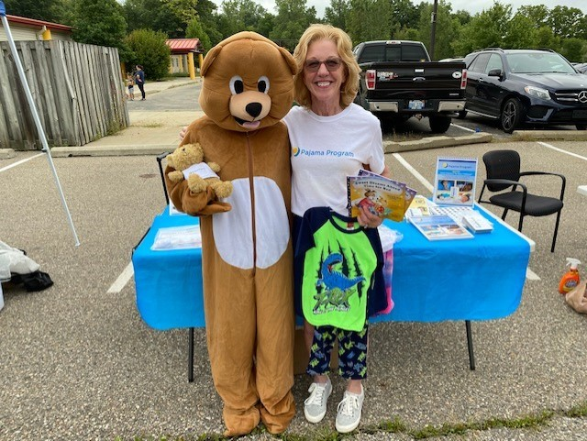
In March of 2022, 3 of the sub-recipient programs took part in a pilot program with the Pajama Program. The Pajama Program provides programming to include sleep health education for children, parents, caregivers, and educators in efforts to ensure that children are fully supported at bedtime. The National Pediatric Association recognizes sleep as a critical factor in the overall health of children.

The pilot included 13 classrooms and approximately 180 children and their families. Pajama Program Pilot Classrooms: (2) Lincoln, (10) YCS and (1) Whitmore Lake. Classroom implementation covers 2 weeks which includes materials sent home to families to reinforce learning. Based on the success of the polit, in March 2023, the Pajama Program was expanded to include 42 classrooms and approximately 450 children.

A Parent Follow Up survey was conducted in May 2023.
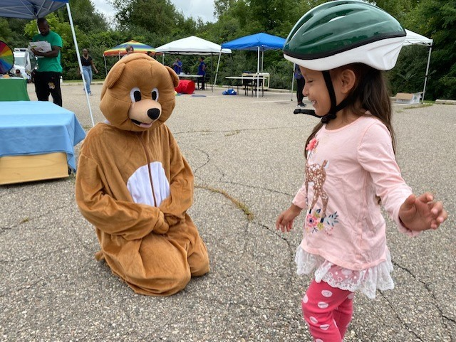
- 14% of parents/caregivers completed the survey about six weeks after program delivery.
- Parents/caregivers had received training from Head Start staff (82%) and/or their child had. received the classroom curriculum (88%).
- 33% of parents report that they are now following a bedtime routine.

- 51% reported that they are now doing calming activities like reading or drawing before bedtime.
- 73% of reporting parents say they are now providing healthy snacks before bed.
- 25% of parents reported that they are using the materials they received from the program.
- 93% of parents reported that they are turning off TV and other screens before bedtime.
- 60% report that they are getting their children to bed closer to 8:00 pm.
- 80% of parents report that they are doing what they can to keep their child’s sleep space quiet, cool, and dark.
- 33% report that their children are getting more and/or better sleep.
- Most parents (90%) said that what they and/or their child learned had been helpful to their family.
- 57% of teachers reported that they look for to doing the program again next year.
- 88% of teachers reported that nap time was easier, and children were engaged.
- 100% of Family Support Staff reported that the program information was helpful to parents.

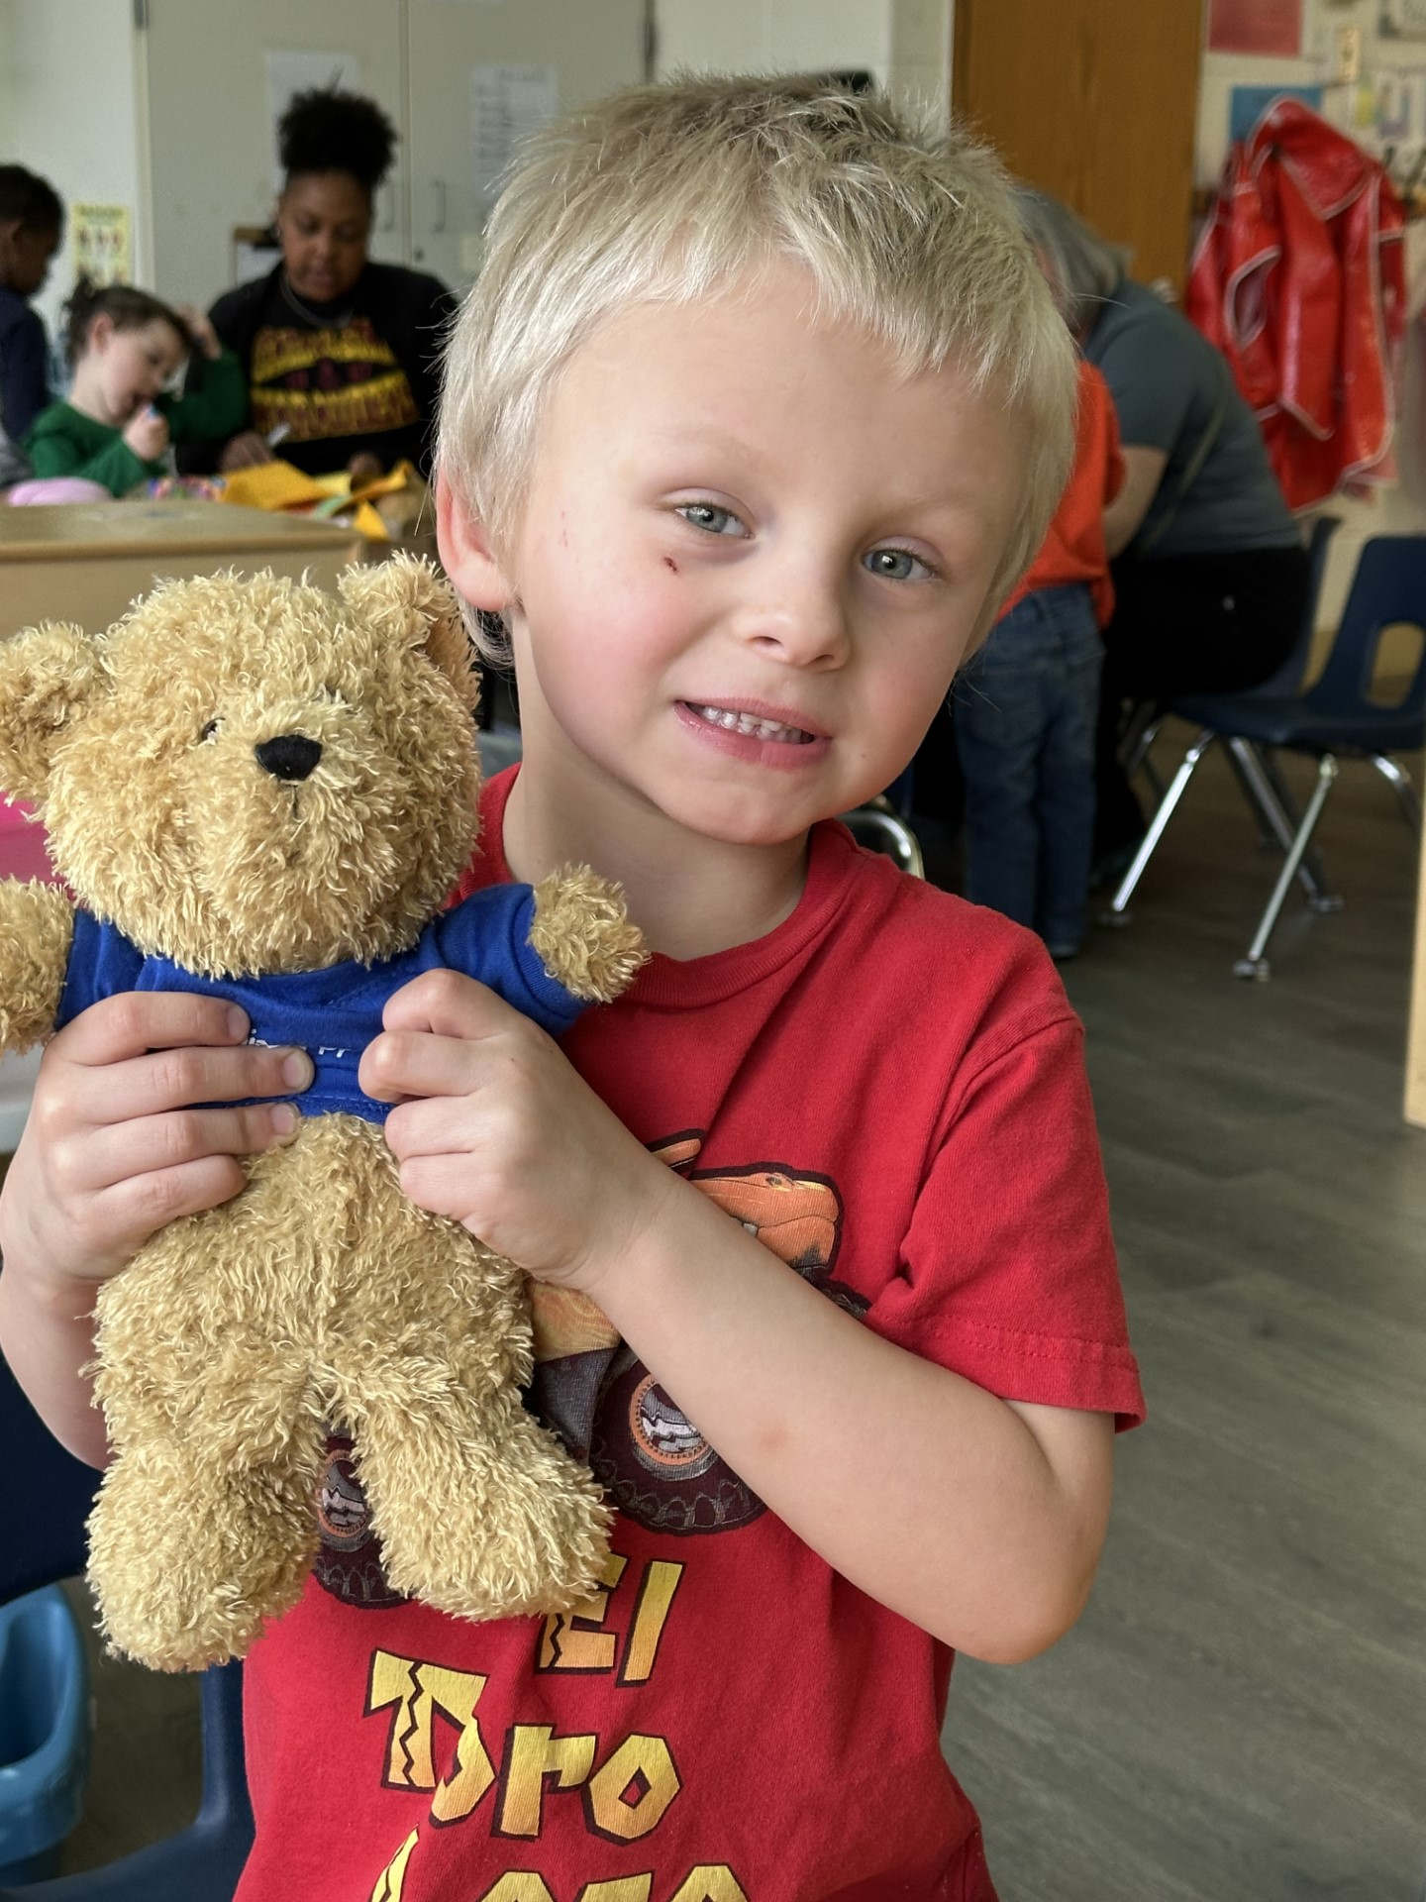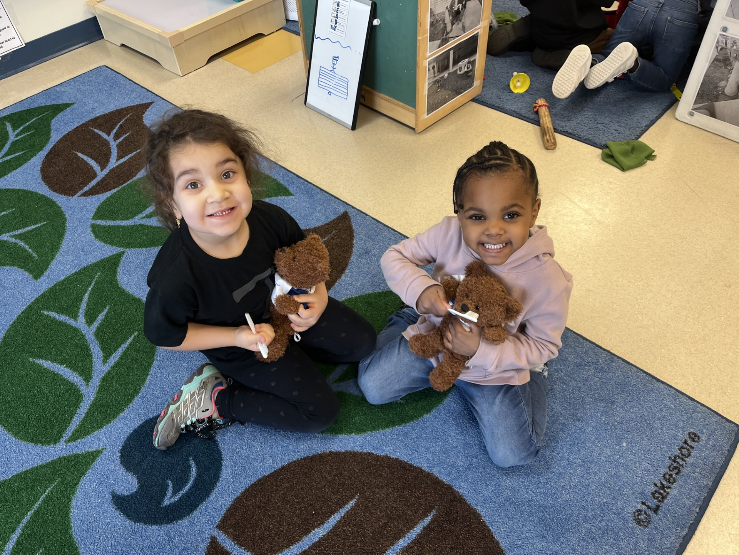

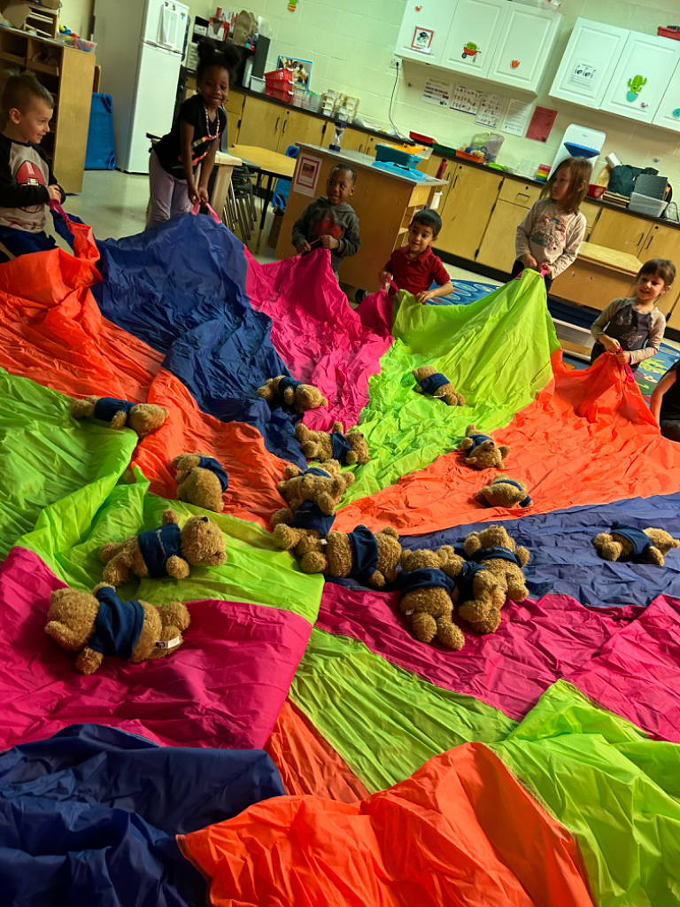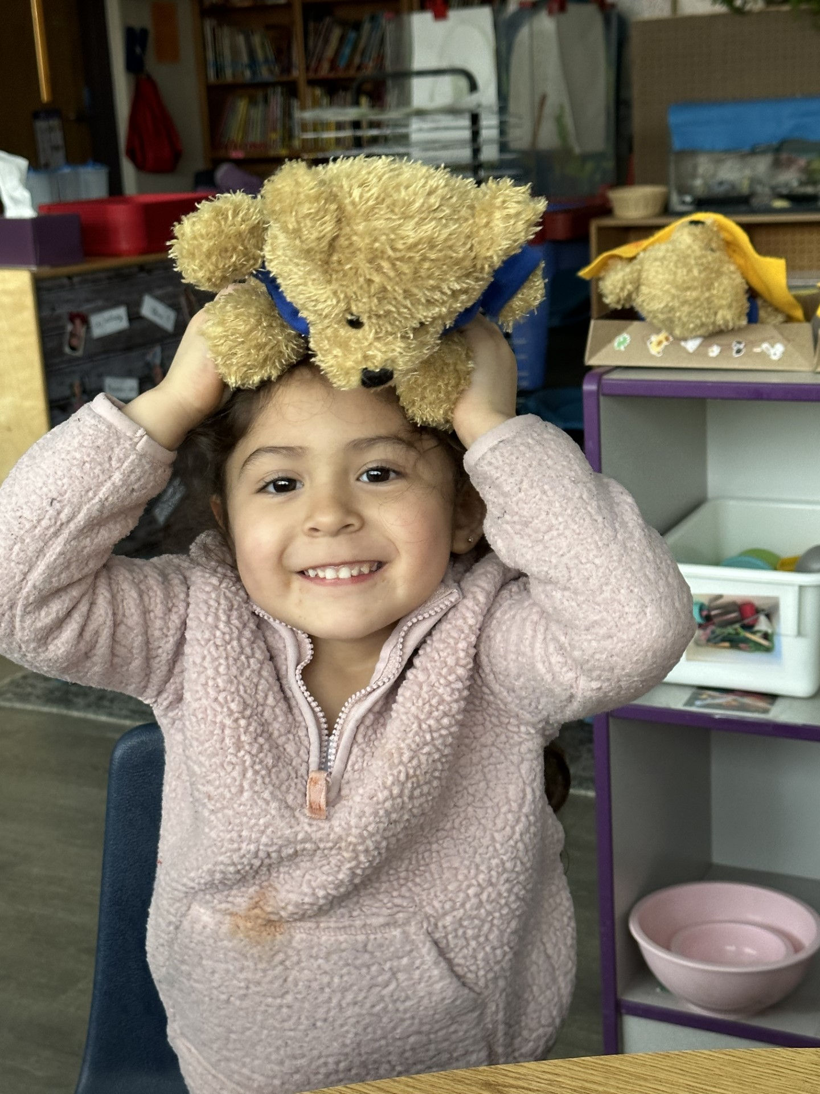

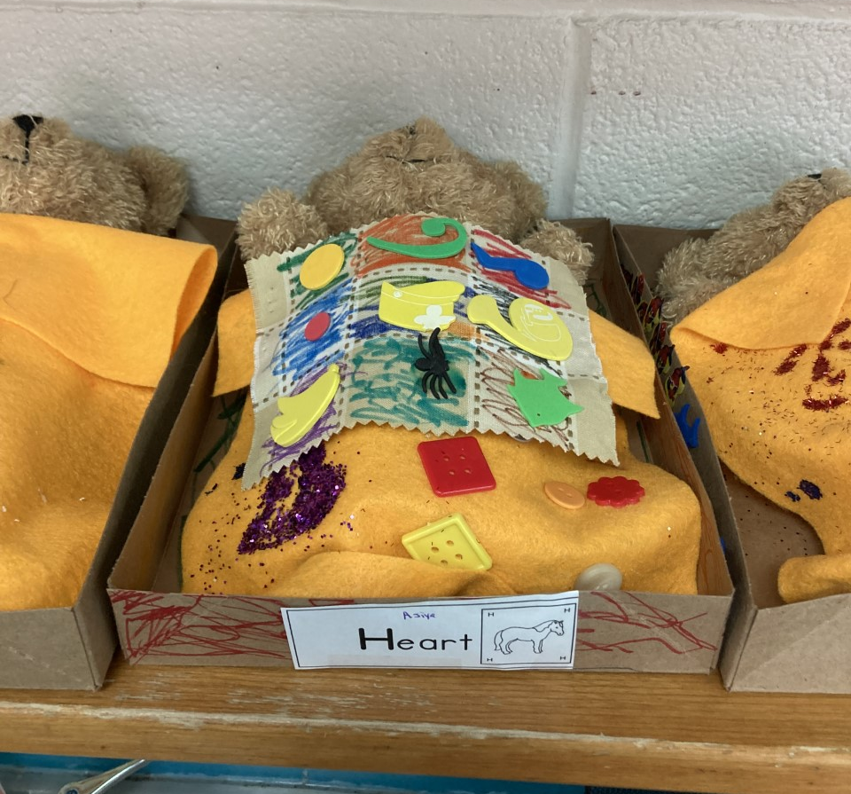

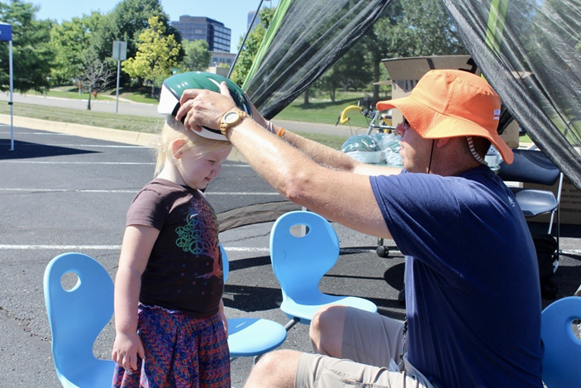
Summer Health Expos
The recipient provided Health Expos Health Expo’s on August 12, 2022, at Ann Arbor Westermann Preschool and August 26, 2022, at Ypsilanti Beatty Early Learning Center. These events provided families with enrollment information, community resources and health screenings.

Site | Attendance | Community Partners | Hearing | Hemoglobin | Lead | Vision
Ann Arbor | Families 46  Adults 61  Children 84  Total 145 | WCHD Public Nursing  WCHD Hearing and Vision Team  UM Mott’s Injury Prevention Program  Head Start Policy Council  Early On  Early Head Start  WIC  Pajama Program  Covington/Meemic Insurance  Regie’s Rainbow  ASQ Screenings  Dental Health  Washtenaw Area Council for Children  Bike Helmets  Food Gatherers  Kona Ice | 38 | 13 | 16 | 37
*All Ann Arbor, Whitmore Lake and Early Head Start families were invited to the Ann Arbor event.

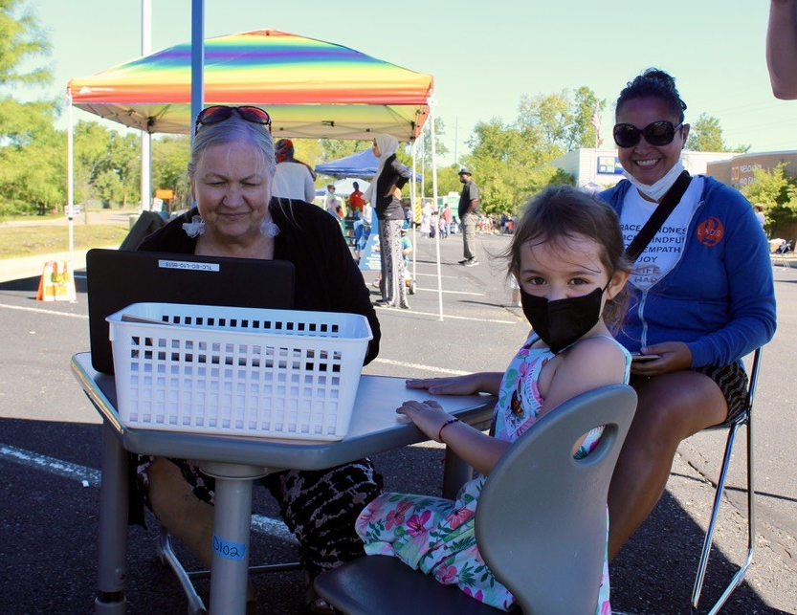
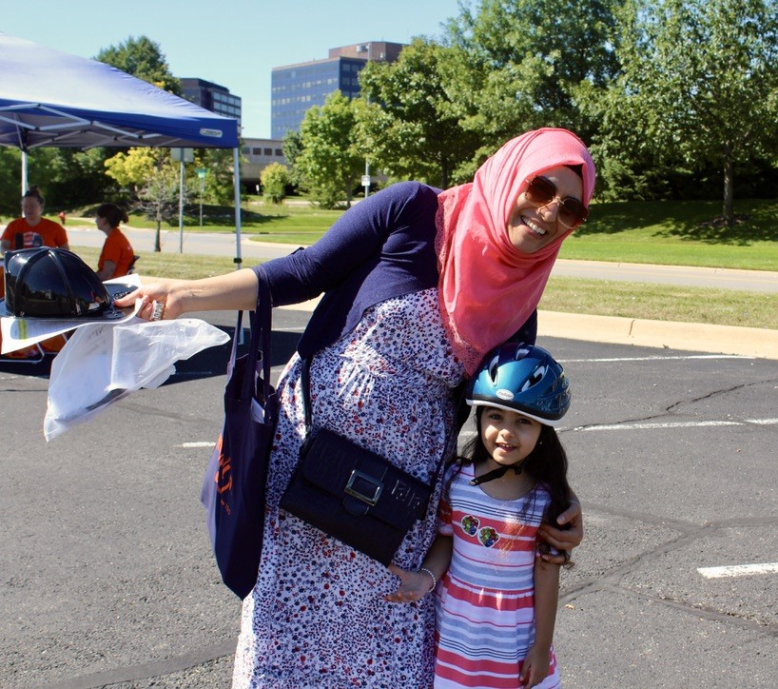

Site | Attendance | Community Partners | Hearing | Hemoglobin | Lead | Vision
Ypsilanti | Families 30  Adults 45  Children 39  Total 84 | WCHD Public Nursing  WCHD Hearing and Vision Team  Head Start Policy Council  Early On  Early Head Start  WIC  Pajama Program  Covington/Meemic Insurance  Regie’s Rainbow  ASQ Screenings  Dental Health  Washtenaw Area Council for Children  Bike Helmets  Food Gatherers  EMU Dept of Psychology  Kona Ice | 23 | 10 | 9 | 23
*All Ypsilanti Head Start, Lincoln and EHS families were invited to the Ypsilanti event

2022 WISD Early Childhood Conference
Each year the program provides an Early Childhood Conference for teaching staff, family support staff and administrative staff. Session topics and keynote speakers are chosen after reviewing program data, staff interest forms and program plans for the upcoming program year. The 2022 Early Childhood Conference was attended by 130 early childhood professionals and featured sessions on a wide variety of topics including Building Positive Relationships with Families, Socially Just Practices, Strengths Based Approaches to Autism, CLASS, Social Emotional Learning and much more! The grounds of Pineview Church set the stage for our theme, A County Fair with Early Childhood Fair! Featuring carnival style games, great food, high quality professional development sessions, and the Early Childhood Market where teachers could shop for materials to enhance their learning environments, this conference sets the stage for a year of learning and fun together!

